12 Port 1U 10-inch CAT5e UTP SOHO UTP PATCH PANEL (PPAN-12-10)
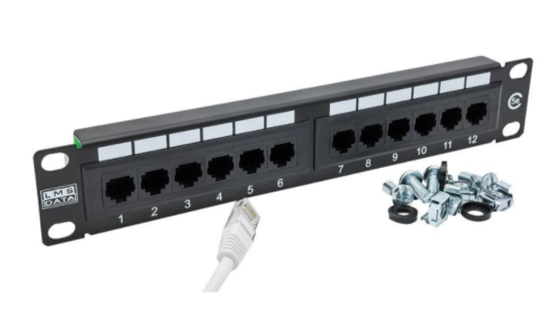

Description
The LMS Data PPAN-12-10 is 12 Port certified CAT5e UTP Patch Panel which is
designed as a SOHO (small office home office) 10-inch design. Being compact its design to fit in a range of 10-inch data cabinets found in homes and small offices.

Fully Gigabit Ethernet certified means its ideal for running legacy and advanced networking protocols to Gigabit Switches up up to 1000Mbps. Also ideal for telecom, VoIP, CCTV-IP and other Ethernet based standards.

Long-life, nickel plated female RJ45s, robust construction with colour-coded rear Krone(tm) KATT type IDC for both TIA-568A/B terminations.

Need to upgrade your current 10-inch structured cabling solution to Category 5e? The new LMS Data PPAN-12-10 is an effective and of course competitive solution for the latest networking technologies, all with the added benefit of a 10-inch wide design. Ideal for SoHo (small office, home office) applications such as homes, branch offices or anywhere a compact data enclosure is required. The PPAN-12-10 is ideal for running the latest Ethernet technologies including Gigabit (1000BaseT), VoIP and of course any legacy applications you maybe required to run. Robust in design with standard KATT IDC connectors, the PPAN-12-10 from LMS Data also benefits from the 25-year structured cabling warranty, for extra piece of mind.

Key Features:
- Certified CAT5e Performance for Gigabit Ethernet
- 10-inch SOHO Compact Design for 10-Inch Cabinets
- Popular Krone(tm) KATT Dual Purpose IDC Punchdown
- Removable Rear Cable Management Bar for Cable Anchoring
- Part of the Synthesis 25-Year Warranty Solution

specifications:
- 12-Port, 10-inch wide Category 5e Patch Panel
- Compact and robust 1U form-factor design
- Exceeds current CAT5e (enhanced) performance
- TIA-EIA-568A/B with Krone AT&T (KATT) IDC
- Phosphor bronze and Nickel IDC connectors
- Gold over Nickel IDC connectors RJ45 connectors
- Supports 22 to 26 AWG conductor diameters
- Port identification and labelling facility
- Ideal for 10-inch Enclosures, SoHo Cabinets

Applications:
- Office, Education and Home Structured Cabling Installs
- Ideal for Gigabit Ethernet (1000Mbps) Data Networks
- Create fault tolerant LANs by simply patching ports

Product Code:
- Part Number: PPAN-12-10
- EAN: 8400800020680
- Weight: 0.3Kg approx.

Technical Specifications:
- Port Count 12 Ports UTP
- Dimensions 1U 19-Inch Design Format
- Conformance TIA-EIA-568A/568B Coded IDC
- Performance 10/100/1000Mbps Gigabit Compliance
- RJ45/IDC Connects Nickel and Phosphor Bronze
- Port Identification Numbered and Bespoke ID Marker
- Fixings Supplied M6 Nuts and Bolts
* Specifications and product design are subject to change. E&OE.

